**Imaging**

1. Turn the EVOS Fl Auto 2 on, and ensure the mount designed to hold the slides is attached and selected in the program.
2. Insert the slide into the spot for the top slide in the mount
3. Select “Trans” as the light type and use the side of the frame as a reference to adjust focus and brightness. Make sure the scalebar is shown, using the button in the button in the bottom right.
4. Locate the tissue sample and change the zoom to “10x,” adjusting brightness and focus as needed.
5. Take 5 captures of the target tissue, aiming to capture new tissue with each photo to create a “map” of the tissue using the “Area View” button
6. Use the Area View button and the previous captures to identify areas of good cellular segmentation. Go to these areas, change the zoom to “20x”, adjust brightness and focus as needed, and take a capture of the zoomed in region. Repeat this 5 times.
7. Once the captures are complete for a sample, save the newly obtained captures as .tif images.
8. Repeat steps 4-7 for each sample as needed. Make sure to save each sample individually, even if they are on the same slide.
9. Export the saved images to an external storage device.

**Cell detection**

*This protocol is designed for use with Cellpose. If Cellpose is not installed, please visit* [*https://github.com/mouseland/cellpose*](https://github.com/mouseland/cellpose) *and follow the installation instructions. Further information on Cellpose can be found at* [*https://cellpose.readthedocs.io/en/latest/*](https://cellpose.readthedocs.io/en/latest/)*.*

1. This protocol will use a previously trained model, adipcyte_count_v##, to detect adipocytes
2. If the custom model is already implemented, skip to step 5. Otherwise, the model will need to be installed and implemented.
3. Install adipcyte_count_v## from XXXX, and place it into the “Downloads.”
4. Add the custom model to Cellpose’s model list by copying the path of the model (shift + right click, “Copy as Path”) and using “cellpose --add_model MODEL_PATH” in the cellpose environment.
5. Make a folder called “images” in the directory where the Cellpose environment is located. Folders for testing images and projects can be made here.
6. Copy the 20x images of the samples and put them in into individual sample folders in the “images” directory. Each sample should get its own folder.
7. Open the Cellpose GUI by running “cellpose” in the environment. Drag and drop an image from the 20x sample folders into the GUI to view it. The pink circle below the image represents the current setting for the diameter of the cells. Use the “calibration” button and/or manually edit the diameter to approximate the mean diameter of the cells.
   1. The mean diameter is often not the same for each tissue sample, each sample folder will likely have different approximated mean diameters.
   2. The diameter is NOT in micrometers, it is in *pixels*. Experiment with the size until a good average is obtained, as this value will be used for the 5 images from this sample
8. Close the GUI and write down the value for the mean diameter.
9. In a text file, write a command to specify the detection process. Specify the location of the images, which model to use, the diameter of the images, which channel to use (0 if H&E stain), and how to save the output. Here is an example:

**cellpose --dir *DIRECTORY_OF_SAMPLE_IMAGES_TO_BE_RUN* --pretrained_model adipocyte_count_v## --diameter 240.0 --min_size 100 --chan 0 --exclude_on_edges --save_tif**

There are many more specifications that can be used to improve or optimize the process, use “cellpose -h” or refer to <https://cellpose.readthedocs.io/en/latest/cli.html> for additional options.

1. Run the program. Once the detection is finished, open the Cellpose GUI and drag the image into the GUI. The “ROIs,” or the individual cells, should be overlayed onto the image like this:

1. Manually edit any errors, using Ctrl+Left Click to remove ROIs and Right Click to draw new ROIs.
   1. Decide what types of detections should be recorded, and *be consistent*
   2. Change the view to “grayscale” to help distinguish the masks from the staining

The program has highlighted most cells correctly, but there are some errors to be fixed. Below are some examples of types of errors that should be manually fixed:

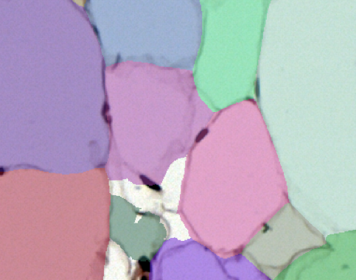 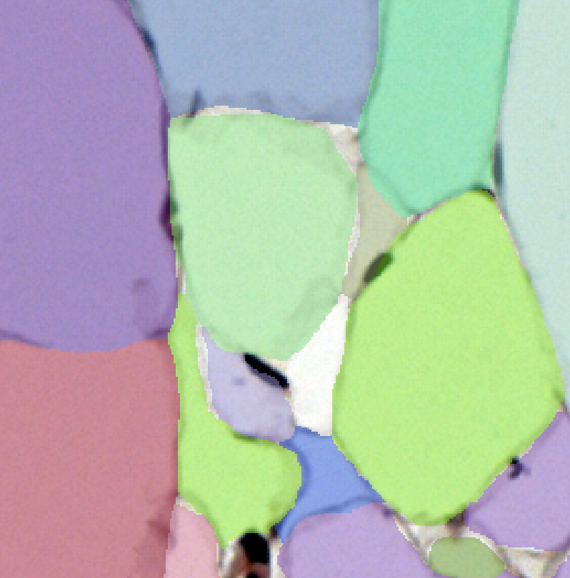

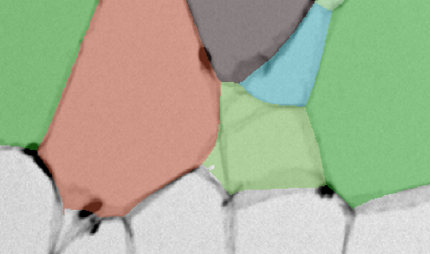 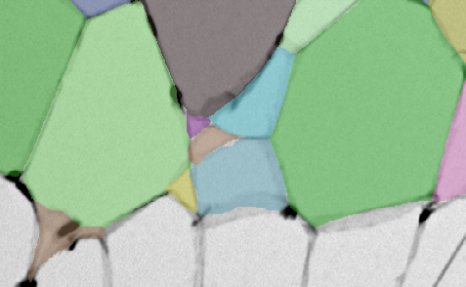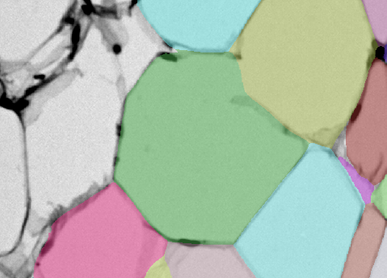 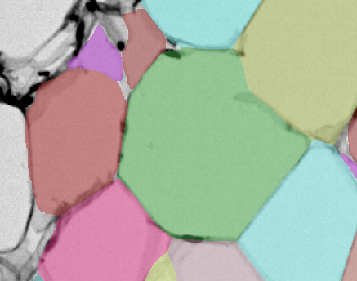

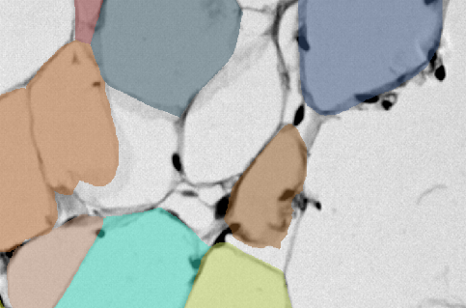 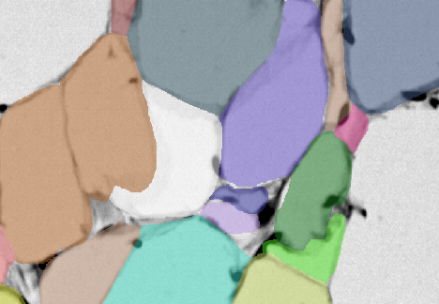

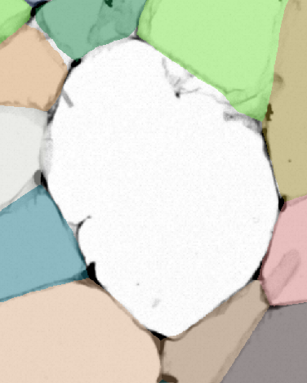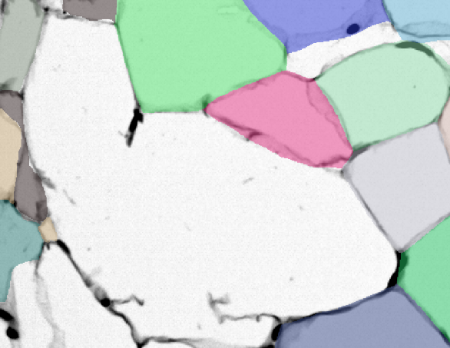

These two images are cells that weren’t detected by the script. The protruding membranes and indented sides suggest that these gaps consist of more than one cell. Be consistent with how these exceptions are segmented, the left region was split into two cells and the right region was split into three cells.

1. Save the ROIs as a .zip using the *File -> Save outlines as .zip archive for ROIs…,* and use Ctrl+S to save the image + mask overlay as a _seg.npy file.
2. Repeat steps 6-11 for all samples

**Cell Count**

1. Open QuPath and create a new project for cell count. If QuPath is not installed, use <https://qupath.github.io/> for installation.
2. Click on “Add Images,” then drag and drop the .tif images or give their directory. This will add the images to the project.
3. Open an image in QuPath by selecting it under the project. Drag and drop the exported ROI .zip folder for that image into QuPath, and they should get implemented as annotatiopns overlayed onto the image like so: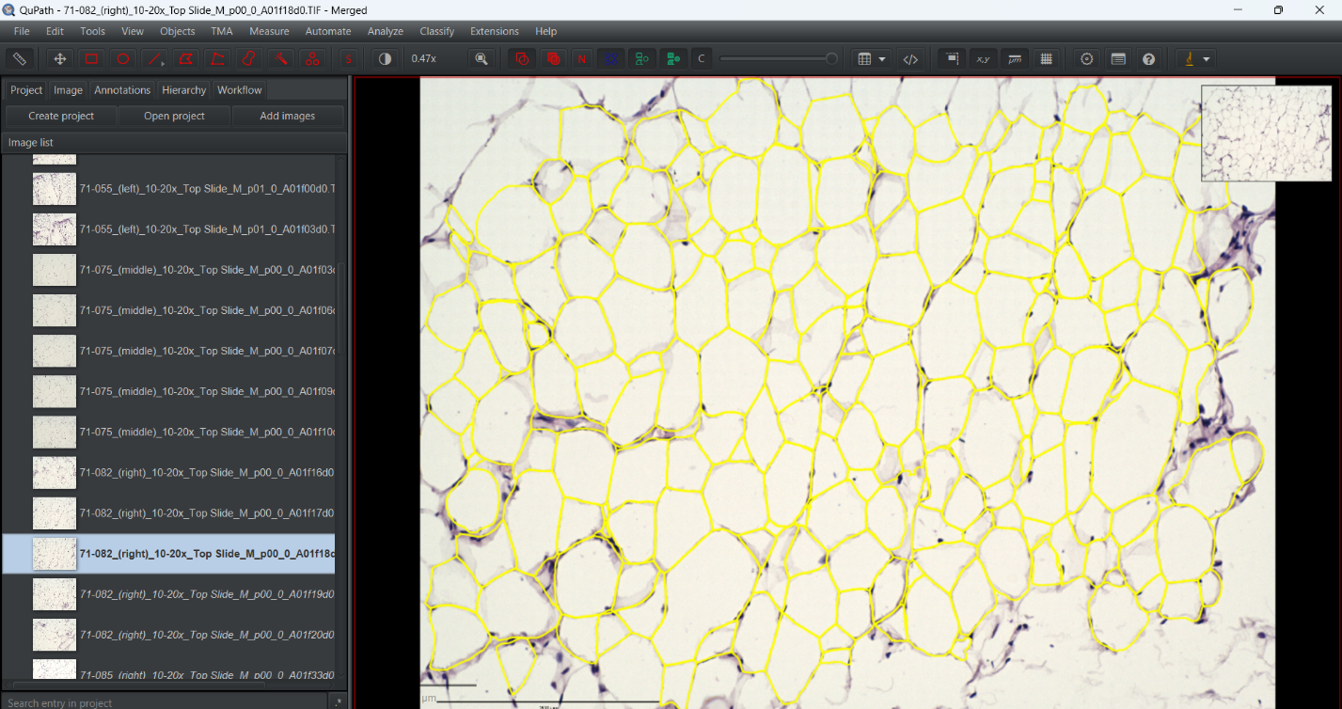
4. Convert the annotations into detections using the “annotation_to_detection” script. To do this, open the “Script Editor” under “Automate,” then click *File -> Open* and find the directory with the script. Click “Run” once the script is accessed. The annotations should all be converted to detections, which can be accessed under the “Hierarchy” tab.
5. Locate areas representative of uniform cell count in the image.
6. Select annotation creating tools (rectangle, closed polygon, etc.) to create an annotation around the cell counting area. Record the area of the annotation and the number of detections (located in “Measurements”) in an Excel file. Do this 3 times per image.
7. In Excel, convert the area from um^2 to mm^2, then divide the detetions by the mm^2 area.
8. Average the ratios from each **sample** to get one average for cell count/mm^2 per sample.
9. Make headers for the treatment groups and paste the sample averages below them to use for statistical analysis.
10. The variances are not equal, so the Welch’s Test will be performed to determine if there are significant differences. Use an online calculator or an Excel add-in like <https://real-statistics.com/free-download/real-statistics-resource-pack/>
11. If there are significant differences, the Games-Howell Post Hoc Test will be performed to determine which groups are significantly different. Use an online calculator or an Excel add-in.
12. For each treatment group, obtain the average, sample standard deviation, standard error mean, and the count. Below this, put a list of integers starting from one and increasing for each treatment group. There should be one repeat of the integer for each sample point in the group. These will become the X axis for the bar-scatter plot.
13. Create a bar graph to represent the data. Create horizontal labels for the categories, then add a series for the group averages. This should be what the bars represent.
14. Add another series for the values from each sample. This will appear as bars, but this can be changed by changing the series type to a scatter plot. After this, edit the series’ X axis to be the correct integer list made earlier so that the plots line up with the correct bar. Repeat this as needed per treatment group.
15. Clean up the bar graph, indicate significant differences by overlaying asterisks for each difference, and add error bars by using the “custom” -> “specify values.” Select all the SEM values in the order that the groups are arranged in the graph for both the positive and negative values, and this will apply the correct SEM to each group.

**Diameter Assessment**

1. Create a new project in QuPath for diameter assessment.
2. Click on “Add Images,” then drag and drop the .tif images or give their directory.
3. Open an image in QuPath by selecting it under the project. Drag and drop the exported ROI .zip folder for that image into QuPath.
4. Convert the annotations into detections using the “annotation_to_detection” script.
5. With all detections still selected, under *Analyze -> Calculate features -> Add shape features*, add all metrics listed except “Nucleus/Cell area ratio.”
6. Ensure there are classifications to designate between the cells that pass and the cells that fail the classification checks. To add more annotations, right click on the current classifications in the “Annotation” page and name a new classification.
7. Go to *Classify -> Object classification -> Create single measurement classifier*, and establish the following classifiers:
   1. Circularity
      * Object filter: Detections (all)
      * Channel filter: No filter (allow all channels)
      * Measurement: Circularity
      * Threshold: 0.6
      * Above threshold: The classification designated to mark cells above the threshold. This example uses “Positive.”
      * Below threshold: The classification designated to mark cells below the threshold. This example uses “Negative.”
      * Classifier name: Circularity
   2. Solidity
      * Object filter: Detections (all)
      * Channel filter: No filter (allow all channels)
      * Measurement: Solidity
      * Threshold: 0.9
      * Above threshold: Positive
      * Below threshold: Negative
      * Classifier name: Solidity
   3. Minimum area
      * Object filter: Detections (all)
      * Channel filter: No filter (allow all channels)
      * Measurement: Area um^2
      * Threshold: 250
      * Above threshold: Positive
      * Below threshold: Negative
      * Classifier name: Minimum area
   4. Minimum diameter
      * Object filter: Detections (all)
      * Channel filter: No filter (allow all channels)
      * Measurement: Min diameter um
      * Threshold: 21
      * Above threshold: Positive
      * Below threshold: Negative
      * Classifier name: Minimum diameter
8. Go to *Classify -> Object classification -> Create composite classifier*, combine the four measurement classifiers into one composite classifier. Run this classifier using *Load object classifier*. The objects will now be classified based on if they pass the threshold checks like so: 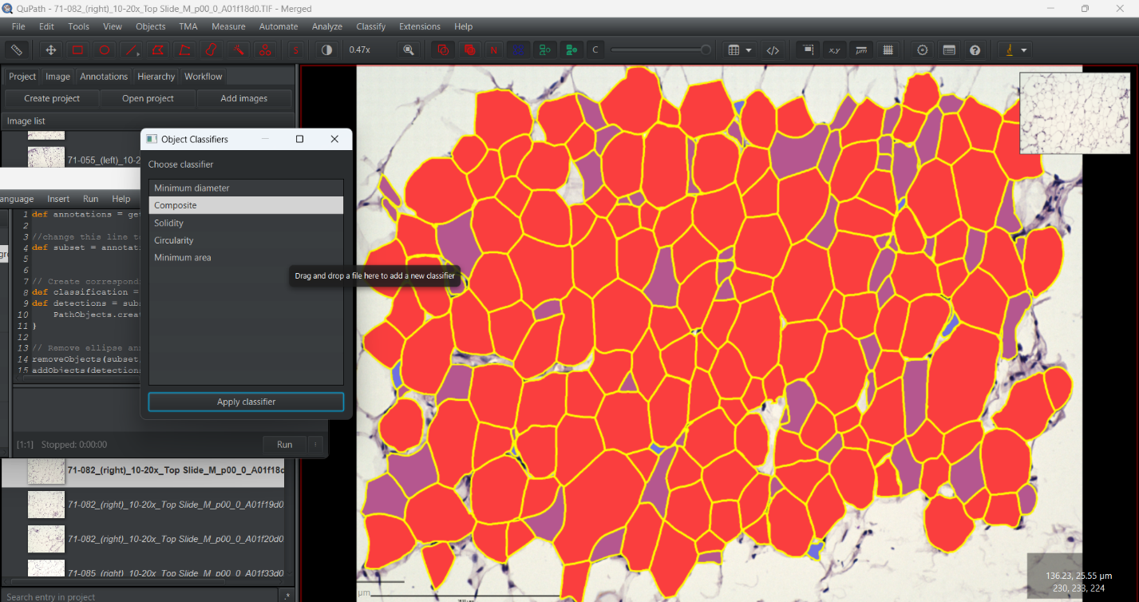
9. Using the script editor, open the “positiveselection” script. Change the names of the classifications in the script if the names are not “Positive” and “Negative,” then run the script. All objects that passed the check should be selected.
   1. Note: sometimes there may be a warning about a measurement not being present when thresholding. If this happens, continue through to this step and examine the hierarchy for the object that did not get applied a classification, and delete it.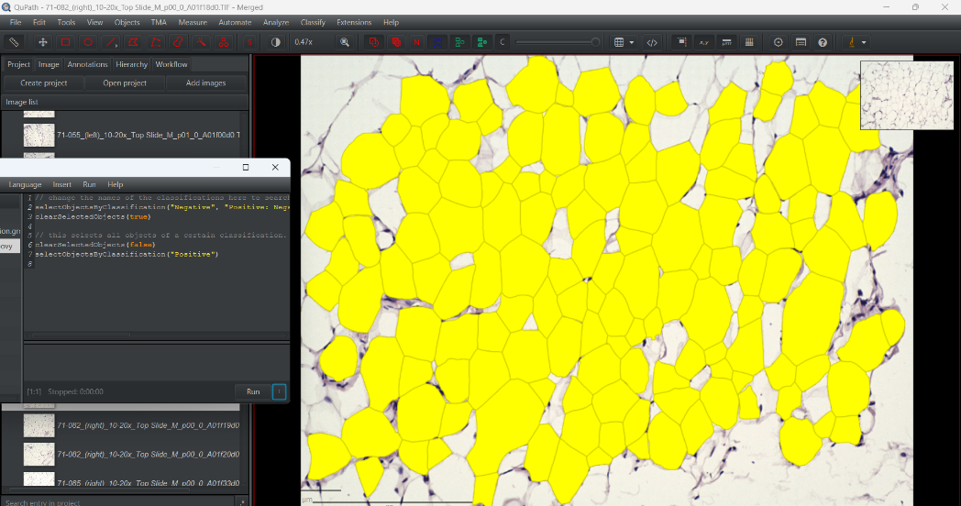
10. Export the object measurements to a .csv file. Repeat steps 3-9 for each frame, using the previously created classifiers.
11. Open all the measurements for a sample in a single Excel tab.
12. In a new tab, make a “Max diameter” column for each treatment group, pasting the values from each sample.
13. Set the “Max diameter” column to conditionally format the top 10% of samples in one color, and the bottom 10% as another color. Sort the table by max diameter.
14. In *Files -> Options -> Add-ins -> Manage Excel Add-ins: Go*, check the Analysis Tool pack and press OK.
15. Create a new column titled “Bins.” This will be the bins the histogram uses for the X axis (max diameter). This example starts at 25 and increases by increments of 5 (25,30,35,etc.) until the highest diameter is reached.
16. In the “Data” tab select “Data Analysis,” then “Histogram.” Input the values in the “Bins” column into the bin range, and enter the values highlighted to represent the bottom 10th percentile in max diameter. Select “Output Range” and enter a tile to output the table to.
17. Select the data in the histogram table, navigate to “Insert scatter with smooth lines and markers.” Change the axis titles and ranges as needed.
    1. OPTIONAL: To add bars beneath the curve, go to *Add chart element -> error bars -> more error bar options*. Set the error bar to minus, no cap, percentage = 100%, and increase the thickness of the error bar. Delete the horizontal bar by right-clicking it and selecting delete.
18. Repeat steps 14-16 to generate histograms for the bottom 10th percentile, top 10th percentile and the range in between the 10th and 90th percentile groups. Here is an example without bars:
19. Clean up the histogram by removing gridlines, changing the line and text color, and making the X axis of all histograms the same to visualize the differences.
20. Add new series to each histogram to represent the different treatment groups. Here is an example of a finished histogram:
21. Repeat steps 18 and 19 until all histograms are ready.
22. Obtain the 10th, 50th, and 90th percentile for max diameter of each sample.
23. Calculate the average of these values for each treatment group, then calculate the sample standard deviation, number of data points per treatment group, and standard error mean ($\frac{σ}{√\left(n\right)})$,
24. Using the same template and procedure as the bar-scatter plot for the cell count, make a bar-scatter plot for the 10th, 50th, and 90th percentile max diameter. Here is an example:
25. Repeat steps 22-24 for the area of the cells.
26. Indicate significant differences and put finishing touches on charts.